Based on the following description, create a data model using Crow’s Foot notation. Use Astah to create your data model.

Description: Amli Residential is a luxury apartment management company. The company has apartment complexes in many cities. As their business grows, the company would like to create a database to track various data and help monitor their growth. Each apartment complex has a unique id used to identify it. Apartment complexes also have a name (example, Amli Buckhead), an address and number of units. Each apartment complex has multiple amenities (such as swimming pool, gym, yoga room, etc.). The amenities are associated with the apartment complex. Each apartment complex is managed by one or more staff members. Staff members have an employee id, name, phone number, email address and title. Each staff member can only work with one apartment complex. Each apartment complex has many renters and each renter could rent multiple apartments with Amli. In this case the starting rent date and ending rent date need to be recorded.

Tasks:
- Create a data model using Crow’s Foot notation showing all the entities, attributes for each entity and the identifier(s) for each entity.
- Add relationships between these entities as described. Remember that data models should be based on requirements gathered from the user. If you need more information, ask your client (instructor).
- Export as Image (Tools menu) and add image to a Word file.
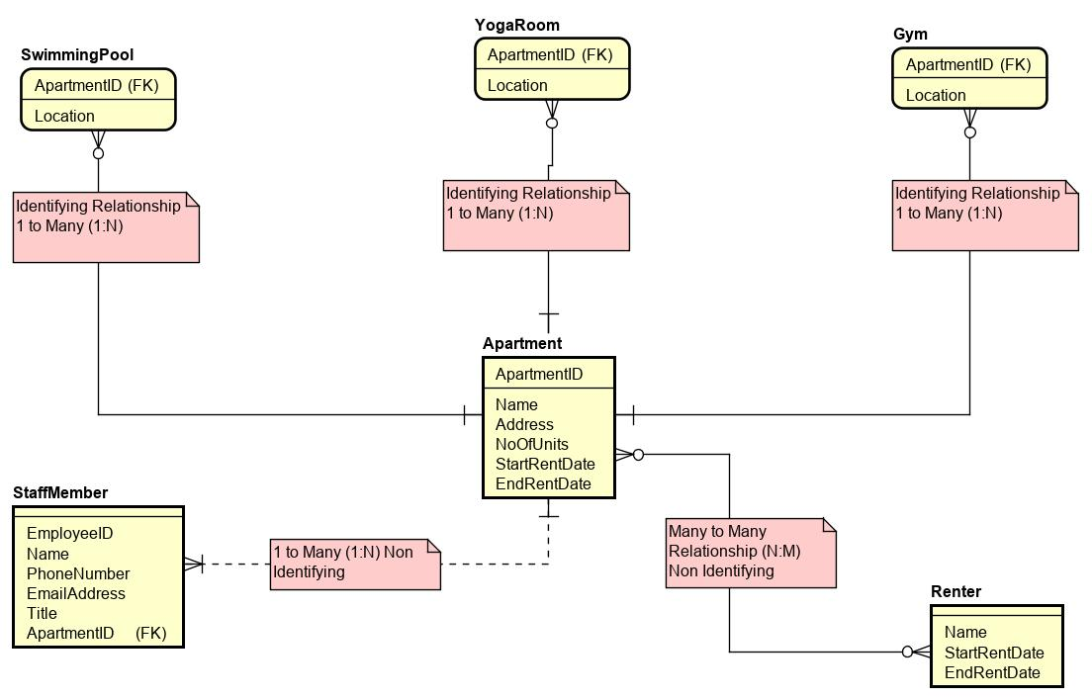
- Below the data model, briefly describe your data model. Explain the decisions made regarding cardinalities, type of entities and relationships.

First, APARTMENT has three ID dependent entity SWIMMING POOL, GYM, and YOGA ROOM. Meaning they share an identifying relationship. That is one apartment can have no or many swimming pools, gym, or yoga room, but those amenities can only belong to one apartment.
The relationship between STAFFMEMBER and APARTMENT is Non identifying relationship and it is a 1 to many (1: N) relationship. This is because each apartment is managed by one or many staff members, but each staff member can only work with one apartment complex.
The relationship between APARTMENT and RENTER is also non identifying but a many to many (N:M) relationship. This is because a renter rents many apartments and each apartment complex is rented by many renters.

- Submit the Word file on D2L.

